Global Life Expectancy Paradox

24ADI204 - DATA SCIENCE AND VISUALISATION
Submitted by

DHIVYA A – 24BAD020

HARSHAVARTHAN SB – 24BAD033

JAYA KRISHNA G - 24BAD042

LATHIKA M - 24BAD062

in partial fulfilment for the award of the degree of

BACHELOR OF TECHNOLOGY

IN
ARTIFICIAL INTELLIGENCE AND DATA SCIENCE


KUMARAGURU COLLEGE OF TECHNOLOGY
(An Autonomous Institution affiliated to Anna University, Chennai)
Post Box No: 2034, Coimbatore - 641049

APRIL 2026

BONAFIDE CERTIFICATE

Certified that this project report “Global Life Expectancy Paradox”
is the Bonafide work of “DHIVYA A – 24BAD020
HARSHAVARTHAN SB – 24BAD033 ,JAYA KRISHNA G - 24BAD042 , LATHIKA M - 24BAD062” who carried out the project work under my supervision.

SIGNATURE SIGNATURE

Dr. Sudharson D

HEAD OF THE DEPARTMENT

Department of Artificial Intelligence and Data Science,

Kumaraguru College of Technology, Coimbatore – 641049.

Ms. Rupashini P R

SUPERVISOR

Department of Artificial Intelligence and Data Science,

Kumaraguru College of Technology, Coimbatore – 641049.

The candidates with college register number DHIVYA A – 24BAD020 ,

HARSHAVARTHAN SB – 24BAD033 , JAYA KRISHNA G - 24BAD042 , LATHIKA M - 24BAD062 were examined in the Project Viva-Voce examination held on 30.04.2026.

Internal Examiner External Examiner

DECLARATION
I affirm that the project work titled “Global Life Expectancy Paradox” being submitted in partial fulfillment for the award of B. TECH Artificial Intelligence and Data Science is the original work carried out by us. It has not formed the part of any other project work
submitted for the award of any degree or diploma, either in this or any other University.

Team Member | Signature
Dhivya A | 
Harshavarthan S B | 
Jaya Krishna G | 
Lathika M | 

I certify that the declaration made above by the candidates is true.
Ms. Rupashini P R
Assistant Professor,
Department of Artificial Intelligence and Data Science, Kumaraguru College of Technology,
Coimbatore – 641049.



FINAL PROJECT REPORT
Global Life Expectancy Paradox
"Does Wealth Truly Buy a Longer Life?"

Course Name & Code: 24ADI004 - Data Science and Visualization

Submitted by
Team 02
Team Members — Names & Roll Numbers

Team Member | Roll Numbers
Dhivya A | 24BAD020
Harshavarthan S B | 24BAD033
Jaya Krishna G | 24BAD042
Lathika M | 24BAD062
Faculty Name — Shriaarthy E
Academic Year — 2024 - 2028

Executive Summary

This report presents the complete findings of Team 2's seven-week data science project undertaken as part of the course 24ADI004 — Data Science and Visualization. The project interrogates a fundamental global question: Does national wealth guarantee a longer life for its citizens? Using the World Health Organization (WHO) Life Expectancy dataset sourced from Kaggle, the team conducted a full-cycle data science pipeline spanning data ingestion, statistical profiling, cleaning, exploratory analysis, feature engineering, dimensionality reduction, and visualization.

Problem Statement
Life expectancy, one of the most comprehensive indicators of a nation's overall development, is influenced by a complex interplay of economic, social, and health-system factors. The project's central research question 'Does wealth truly buy a longer life?', challenges the simplistic assumption that GDP alone determines health outcomes. The analysis demonstrates that while economic prosperity contributes significantly, social investments in education and healthcare infrastructure are equally, if not more, impactful.

Dataset
The WHO Life Expectancy dataset encompasses 2,938 records across 193 countries and 16 years (2000–2015), comprising 22 variables that capture health, economic, and demographic dimensions. The target variable is life expectancy in years. The dataset presented notable data quality challenges — 2,563 missing values spread across 14 columns, severe right-skewness in economic variables, and high outlier proportions in disease burden indicators — all of which were systematically addressed during preprocessing.

Key Findings
- Education is the strongest positive predictor of life expectancy (Pearson r ≈ +0.75), surpassing even GDP in predictive strength.
- Income composition of resources (a Human Development Index sub-index) correlates at r ≈ +0.72 with life expectancy, confirming that the quality of how income is distributed matters beyond its magnitude.
- Adult Mortality (r ≈ −0.70) and HIV/AIDS prevalence (r ≈ −0.57) are the strongest negative predictors.
- The life expectancy gap between Developed and Developing nations persisted at approximately 11–12 years throughout 2000–2015, despite both groups showing improvement — structural inequality is not self-correcting through economic growth alone.
- Global life expectancy improved from approximately 67 years in 2000 to 72 years in 2015 — a five-year gain attributable largely to reductions in child and adult mortality and the expansion of antiretroviral treatment for HIV/AIDS.
- Principal Component Analysis reduced 18 predictor features to 3 interpretable components capturing 54.3% of total variance, confirming that development level, economic investment, and demographic scale are the three primary axes of variation.

Strategic Insights ("So What?")
The findings collectively argue that health policy cannot be reduced to economic growth alone. Nations seeking to improve life expectancy must invest simultaneously in universal education, childhood immunization programs, and equitable income distribution. The persistent 12-year gap between developed and developing nations underscores the urgency of targeted international health interventions, particularly in Sub-Saharan Africa where the dual burden of high HIV/AIDS prevalence and low schooling creates compounding disadvantages. Policymakers should prioritize the Income Composition of Resources index and years of schooling as leading indicators for health outcome forecasting — these provide earlier and more actionable signals than GDP, which responds more slowly to policy changes.

Table of Contents

Contents

Executive Summary 1
Problem Statement 2
Dataset 2
Key Findings 3
Strategic Insights ("So What?") 3
Table of Contents 4
List of Abbreviations 6
List of Tables 6
List of Figures 7
Chapter 1: Introduction 8
  - Background of the Problem 8
  - Importance of the Study 8
  - Objectives of the Project 8
  - Scope of the Project 9
Chapter 2: Dataset Description 9
  - Source of Dataset 9
  - Dataset Overview 10
  - Description of Features 10
  - Initial Data Issues 11
Chapter 3: Data Preprocessing and Cleaning 11
  - Data Loading and Initial Inspection 11
  - Handling Missing Values 12
  - Outlier Detection — IQR Method 13
  - Data Quality Report Summary 16
Chapter 4: Exploratory Data Analysis (EDA) 16
  - Univariate Analysis 16
    - Life Expectancy — Target Variable 16
    - Core Economic and Social Features 17
    - Development Status Distribution 19
  - Bivariate Analysis 19
    - Economic Factors vs Life Expectancy 19
    - Social and Health Factors vs Life Expectancy 20
    - Temporal Trends (2000–2015) 21
    - Development Status Gap Over Time 22
    - Country Rankings 22
  - Multivariate Analysis 23
    - Full Correlation Heatmap 23
    - 3D Scatter Analysis 23
Chapter 5: Data Transformation and Feature Engineering 25
  - Overview 25
  - Label Encoding 25
  - Log Transformation for Skewness Correction 25
  - MinMax Normalisation 26
  - Z-score Standardisation 26
  - Post-Transformation Validation 26
Chapter 6: Advanced Analysis 28
  - Correlation Analysis 28
  - Feature Selection 28
  - Principal Component Analysis (PCA) 29
    - Methodology 29
    - Explained Variance 29
    - Visualization of Components 30
    - Component Interpretation via Loading Heatmap 30
Chapter 7: Visualization and Dashboard 32
  - Tools and Technologies Used 32
  - Types of Visualizations Produced 32
  - Dashboard Description 33
Chapter 8: Insights and Storytelling 34
  - Key Findings from Analysis 34
    - Education Outperforms Wealth as a Life Expectancy Predictor 34
    - The HIV/AIDS Factor 34
    - The Persistent Development Gap 34
  - Patterns and Trends Identified 35
  - Business and Social Insights 35
  - Decision-Making Based on Results 35
Chapter 9: Conclusion 36
  - Summary of the Project 36
  - Outcomes Achieved 36
  - Limitations 37
  - Future Scope 37
Chapter 10: References 38
Dataset Sources 38
Tools and Libraries Used 38
Technical Documentation and References 39
Research Articles and Learning Resources 39

List of Abbreviations

Abbreviation | Full Form
WHO | World Health Organization
GDP | Gross Domestic Product
HDI | Human Development Index
EDA | Exploratory Data Analysis
IQR | Interquartile Range
KDE | Kernel Density Estimation
PCA | Principal Component Analysis
SDG | Sustainable Development Goal
BMI | Body Mass Index
HIV/AIDS | Human Immunodeficiency Virus / Acquired Immune Deficiency Syndrome
DTP3 | Diphtheria, Tetanus, and Pertussis — 3rd dose immunization
PEPFAR | President's Emergency Plan for AIDS Relief
UNAIDS | United Nations Programme on HIV and AIDS

List of Tables

Table 2.1 — Dataset Overview
Table 2.2 — Feature Description of All 22 Variables
Table 3.1 — Missing Value Report with Imputation Strategy Table 3.2 — Top 5 Outlier Features by IQR Method
Table 7.1 — PCA Component Variance Summary Table 9.1 — Team Contributions

List of Figures

Figure 3.1 — Feature Distributions Before Imputation
Figure 3.2 — Outlier Analysis: Bar Chart and Proportional Donut Figure 3.3 — Before vs After IQR Capping Boxplots
Figure 4.1 — Life Expectancy Univariate Portrait Figure 4.2 — Core Feature Distributions
Figure 4.3 — Health Indicator Distributions
Figure 4.4 — Economic & Social Indicator Distributions Figure 4.5 — Development Status Distribution
Figure 4.6 — Boxplot Grid: Six Key Features
Figure 4.7 — GDP vs Life Expectancy (Quartile & Scatter) Figure 4.8 — Social & Health Factors vs Life Expectancy Figure 4.9 — Mortality & Immunization vs Life Expectancy Figure 4.10 — Mortality Analysis: Compound Risk Factors Figure 4.11 — Strip Plots: Features by Development Status Figure 4.12 — Grouped Analysis by GDP, Income, Schooling Figure 4.13 — Global Trends 2000–2015
Figure 4.14 — Life Expectancy Trend by Development Status Figure 4.15 — Country Rankings: Top 10 and Bottom 10 Figure 4.16 — Pairplot: Six Key Features by Status
Figure 4.17 — Full Pearson Correlation Heatmap
Figure 4.18 — Feature Correlations with Life Expectancy Figure 4.19 — 3D Scatter: GDP, Schooling, Life Expectancy Figure 4.20 — Pivot Heatmap: Status × Year
Figure 6.1 — Label Encoding: Status Before and After Figure 6.2 — Post-Transformation Correlation Heatmap
Figure 7.1 — PCA Scree Plot and Cumulative Variance Curve Figure 7.2 — PCA 2D Projection by Development Status Figure 7.3 — PCA Component Loading Heatmap (PC1–PC6) Figure 7.4 — 3D PCA Projection

Chapter 1: Introduction

Background of the Problem
Life expectancy at birth is one of the most widely used indicators of a nation's overall health and development. It encapsulates the cumulative effect of living conditions, healthcare access, disease burden, nutritional status, and governance quality into a single, comparable metric. Since the turn of the millennium, global life expectancy has improved substantially, driven by advances in medicine, expanded vaccination programs, better maternal and child healthcare, and the international response to epidemic HIV/AIDS. However, this progress has been highly uneven prosperity in some corners of the world coexists with alarming mortality burdens in others.
The core paradox motivating this project lies in the assumption that economic growth alone measured through Gross Domestic Product (GDP) per capita — is the primary determinant of health outcomes. While wealthier nations do, on average, live longer, the relationship is neither linear nor universal. Some low-income nations achieve surprisingly high life expectancy through strong public health systems and educational investments, while some middle-income nations underperform due to structural inequalities and poor health governance. Understanding what truly drives life expectancy — beyond wealth — has significant implications for global health policy, resource allocation, and sustainable development.

Importance of the Study
This project addresses four of the United Nations Sustainable Development Goals (SDGs) directly: SDG 3 (Good Health and Well-Being), SDG 4 (Quality Education), SDG 8 (Decent Work and Economic Growth), and SDG 10 (Reduced Inequalities). By quantifying the relative contributions of economic, educational, and health-system factors to life expectancy variation across 193 nations over 16 years, the project provides an evidence base for understanding where investments yield the greatest health dividends. The findings are particularly relevant for policymakers in developing nations, international health organizations, and researchers working at the intersection of economics, public health, and education.

Objectives of the Project
    - To analyze the WHO Life Expectancy dataset through a complete, reproducible data science pipeline — from raw ingestion to dimensionality reduction.

    - To quantify and compare the relative influence of economic indicators (GDP), social indicators (schooling, income composition), and health-system indicators (immunization coverage, mortality rates) on life expectancy.
    - To identify systematic patterns of missing data and apply statistically justified imputation strategies.
    - To explore distributional properties, inter-variable relationships, and temporal trends through rigorous exploratory data analysis.
    - To apply feature engineering and transformation techniques to prepare the dataset for advanced statistical analysis and machine learning.
    - To reduce the dimensionality of the dataset using PCA and interpret the principal components in real-world terms.
    - To communicate findings through compelling, well-designed visualizations that support data-driven decision-making.

Scope of the Project
This project operates within the boundaries of the WHO Life Expectancy dataset as sourced from Kaggle. The analysis spans 193 countries over the period 2000 to 2015, encompassing 22 variables. The project does not include predictive modelling, machine learning classification, or real-time data integration; however, all preprocessing, feature engineering, and PCA steps are designed to make the dataset fully model-ready for future work. The analytical focus is on descriptive statistics, exploratory visualization, correlation analysis, and dimensionality reduction. All code is written in Python using pandas, NumPy, matplotlib, seaborn, scikit-learn, and scipy.

Chapter 2: Dataset Description

Source of Dataset
The dataset was sourced from Kaggle, originally compiled by Kumar Rajarshi from data published by the World Health Organization (WHO) Global Health Observatory. The WHO collects standardized health, demographic, and economic statistics from member nations as part of its Global Health Observatory programme, enabling cross-national comparisons of health system performance. The dataset combines WHO health statistics with Human Development Index (HDI) data from the United Nations Development Programme (UNDP), providing a uniquely rich, multi-dimensional perspective on the determinants of life expectancy.

Dataset Overview

Attribute | Detail
Source | World Health Organization (WHO) — Kaggle Datasets
Dataset Link | https://www.kaggle.com/datasets/kumarajarshi/life-expectancy-who
Type | Country-wise, yearly panel data
Rows × Columns | 2,938 rows × 22 columns
Year Range | 2000 to 2015
Countries | 193 unique countries
Target Variable | Life Expectancy (years)
GitHub Repository | https://github.com/varthanharsh35-ux/24ADI004_TEAM-2.git
Table 2.1 — Dataset Overview

Description of Features
The dataset contains 22 variables organized into four thematic categories: demographic identifiers (Country, Year, Status), the target variable (Life expectancy), health indicators (Adult Mortality, infant deaths, Measles, Hepatitis B, Polio, Diphtheria, HIV/AIDS, BMI, under-five deaths), economic indicators (GDP, percentage expenditure, Total expenditure), and social/development indicators (Schooling, Income composition of resources, thinness 1-19 years, thinness 5-9 years, Alcohol, Population). A complete feature reference is provided below.

Feature | Type | Description
Country | Object | Name of the country
Year | Integer | Year of observation (2000–2015)
Status | Object | Developed or Developing classification
Life expectancy | Float | Average life expectancy in years — TARGET variable
Adult Mortality | Float | Probability of dying between ages 15 and 60 per 1,000 population
infant deaths | Integer | Number of infant deaths per year
Alcohol | Float | Per capita alcohol consumption in litres of pure alcohol
percentage expenditure | Float | Health expenditure as % of GDP per capita
Hepatitis B | Float | Hepatitis B immunization coverage among 1-year-olds (%)
Measles | Integer | Number of reported Measles cases per 1,000 population
BMI | Float | Average Body Mass Index across the entire population
under-five deaths | Integer | Deaths of children under five per 1,000 population
Polio | Float | Polio immunization coverage among 1-year-olds (%)

Total expenditure | Float | Government health expenditure as % of total expenditure
Diphtheria | Float | DTP3 immunization coverage among 1-year-olds (%)
HIV/AIDS | Float | Deaths per 1,000 live births due to HIV/AIDS (0–4 years)
GDP | Float | Gross Domestic Product per capita in USD
Population | Float | Total population of the country
thinness 1-19 years | Float | Prevalence of thinness among ages 1–19 (%)
thinness 5-9 years | Float | Prevalence of thinness among ages 5–9 (%)
Income composition | Float | Human Development Index — income composition sub- index (0–1)
Schooling | Float | Average number of years of schooling
Table 2.2 — Description of All 22 Dataset Features

Initial Data Issues
Upon initial inspection, several data quality issues were identified that required systematic treatment in subsequent weeks:
    - Missing Values: 2,563 missing cells were distributed across 14 of the 22 columns, representing approximately 8.7% of the total data matrix. The three most affected columns — Population (22.19%), Hepatitis B (18.82%), and GDP (15.25%), reflect the weaker data collection infrastructure in developing nations.
    - Column Name Whitespace: Several column names contained trailing whitespace characters (e.g., 'Life expectancy '), causing KeyError exceptions when accessed. This required immediate stripping after loading using df.columns.str.strip().
    - Distributional Skewness: Features such as GDP, infant deaths, under-five deaths, Measles, and HIV/AIDS exhibited severe right-skewness (skewness > 1), indicating that a small number of countries had extreme values that could distort mean-based analyses and machine learning models.
    - Class Imbalance: Approximately 82.4% of records belong to Developing nations versus 17.6% Developed nations, reflecting real-world country classification but requiring careful consideration in group comparisons.
    - Outliers: High outlier proportions were detected in disease burden indicators HIV/AIDS and Measles at 18.45% each representing genuine real-world heterogeneity rather than data errors.

Chapter 3: Data Preprocessing and Cleaning

Data Loading and Initial Inspection

The dataset was loaded using pandas' read_csv() function, with immediate application of column name stripping to resolve the trailing whitespace issue. The initial inspection confirmed 2,938 rows, 22 columns, and 0 duplicate rows each country-year record was unique. The dataset comprised 20 numerical columns (float64 and int64) and 2 categorical columns (Country and Status). A memory footprint of 797.9 KB confirmed that the entire dataset could be processed in-memory without chunking. Year range validation confirmed observations from 2000 to 2015 with 193 unique countries.

Handling Missing Values
A skewness-based imputation strategy was adopted to ensure that the replacement values accurately represent the underlying distribution of each column. For numerical columns with skewness greater than 1 (indicating right-skewed distributions), median imputation was applied
— the median is resistant to extreme upper-tail values and provides a more representative central tendency than the mean. For approximately symmetric distributions (skewness between
−1 and +1), mean imputation was used. For categorical columns, mode imputation was applied.
This approach resulted in 8 columns receiving median imputation (including GDP, Population, infant deaths, and HIV/AIDS) and 12 columns receiving mean imputation (including Life expectancy, Schooling, BMI, and Alcohol). The complete missing value report and assigned imputation methods are shown below.

Column | Missing Count | Missing % | Imputation Method
Population | 652 | 22.19% | Median (skew > 1)
Hepatitis B | 553 | 18.82% | Mean
GDP | 448 | 15.25% | Median (skew > 1)
Total expenditure | 226 | 7.69% | Mean
Alcohol | 194 | 6.60% | Mean
Income composition | 167 | 5.68% | Mean
Schooling | 163 | 5.55% | Mean
thinness 1-19 years | 34 | 1.16% | Mean
thinness 5-9 years | 34 | 1.16% | Mean
BMI | 34 | 1.16% | Mean
Diphtheria | 19 | 0.65% | Mean
Polio | 19 | 0.65% | Mean
Life expectancy | 10 | 0.34% | Mean
Adult Mortality | 1 | 0.34% | Mean

Table 3.1 — Missing Value Report and Imputation Strategy by Column

Following the imputation procedure, a zero-null validation confirmed that all 2,563 missing cells were successfully replaced. The dataset retained all 2,938 rows — no records were deleted.

Outlier Detection — IQR Method
Outlier detection was performed using the Interquartile Range (IQR) method, a non-parametric technique that does not assume any particular distribution. Outliers were defined as values falling below the lower fence (Q1 − 1.5 × IQR) or above the upper fence (Q3 + 1.5 × IQR). Rather than deleting outlier records, IQR capping was applied: values below the lower fence were replaced with the lower fence value, and values above the upper fence were replaced with the upper fence value. This preserved all 2,938 records while bounding extreme values.

Feature | Outlier Count | Outlier %
HIV/AIDS | 542 | 18.45%
Measles | 542 | 18.45%
Population | 452 | 15.38%
infant deaths | 375 | 12.77%
under-five deaths | 356 | 12.12%
Table 3.2 — Top 5 Outlier Features by IQR Method (before capping)
The outliers in HIV/AIDS and Measles reflect genuine epidemiological heterogeneity — Sub- Saharan nations experience disease burdens orders of magnitude higher than European counterparts. Population outliers are driven by China and India. These are not measurement errors but authentic real-world variation that IQR capping bounds rather than erases.

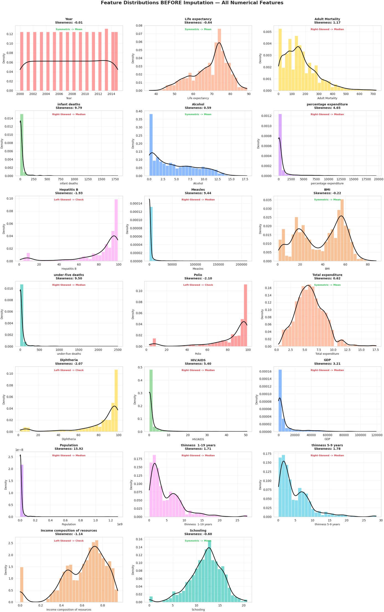

Figure 3.1 — Distributions of All Numerical Features Before Imputation

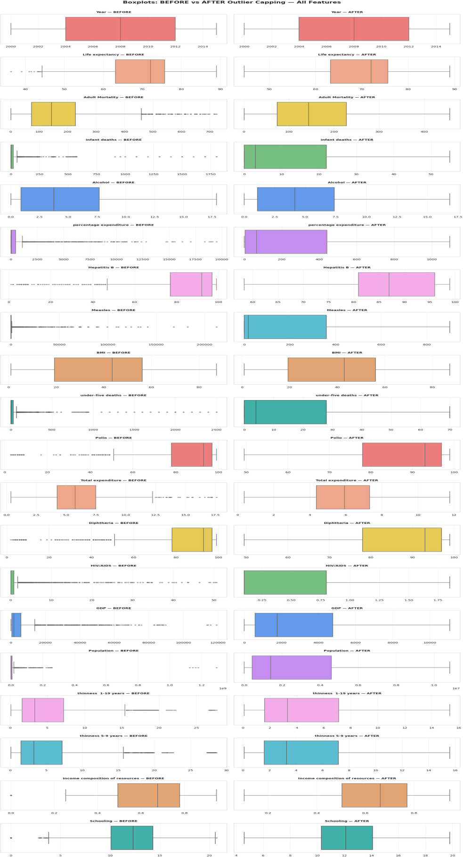

Figure 3.3 — Side-by-Side Boxplots: All Features Before vs. After IQR Capping

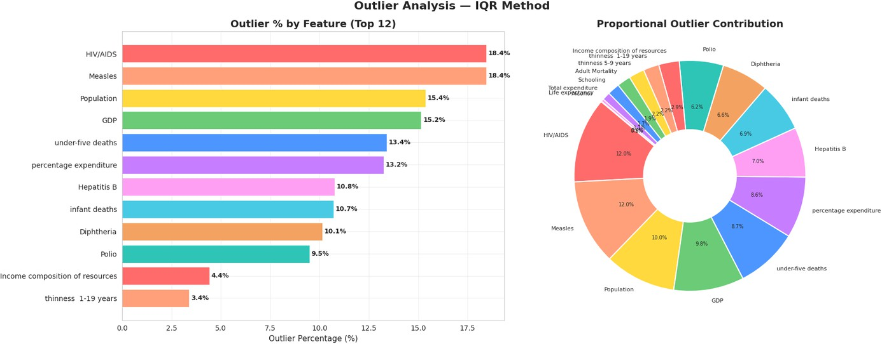
Figure 3.2 — Outlier Analysis: Bar Chart (left) and Proportional Donut Chart (right)

Data Quality Report Summary
After completing all preprocessing steps, the cleaned dataset exhibited the following properties: 0 missing values, 0 duplicate rows, all 2,938 records retained, reduced standard deviation across high-variance features (GDP standard deviation reduced from 14,270 to 3,777), and approximately symmetric distributions for previously skewed columns following log transformation. The cleaned dataset was exported as life_expectancy_cleaned.csv and served as the sole input for all subsequent analytical phases.

Chapter 4: Exploratory Data Analysis (EDA)

Univariate Analysis
Univariate analysis examined each variable independently to understand its distribution shape, central tendency, spread, and outlier behaviour. The primary tools employed were histograms with KDE overlays, violin plots, and boxplots.

Life Expectancy — Target Variable
The target variable exhibits a left-skewed bimodal distribution. The primary peak sits around 72– 75 years, representing the global majority, while a secondary lower peak near 55–60 years represents a distinct cluster of nations — primarily in Sub-Saharan Africa — with persistently low life expectancy. The overall mean and median both approximate 69–70 years. A violin plot stratified by development status reveals a stark difference: Developed nations have a narrow distribution clustered around 78–80 years, while Developing nations show a wide, bimodal spread from 45 to 85 years, with a 12-year median gap between the two groups.

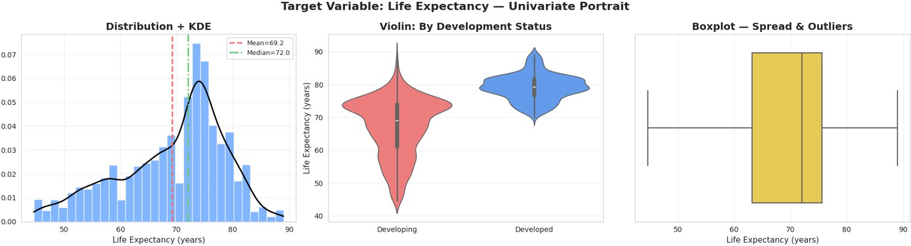
Figure 4.1 — Life Expectancy: Histogram+KDE (left), Violin by Status (centre), Boxplot (right)

4.1.2 Core Economic and Social Features
GDP shows an extremely compressed distribution near zero with a residual right tail even after capping, reflecting persistent wealth inequality across nations. Schooling is the most symmetric feature in the dataset, centered around 11–12 years of average education. Adult Mortality displays a strong right skew, confirming that while most nations have moderate mortality rates, a subset experiences catastrophically elevated rates. BMI is slightly left-skewed with a concentration around 38–50 (population averages, not individual BMI). Alcohol shows a mild right skew consistent with a global majority of moderate consumers and a European high- consumption tail.
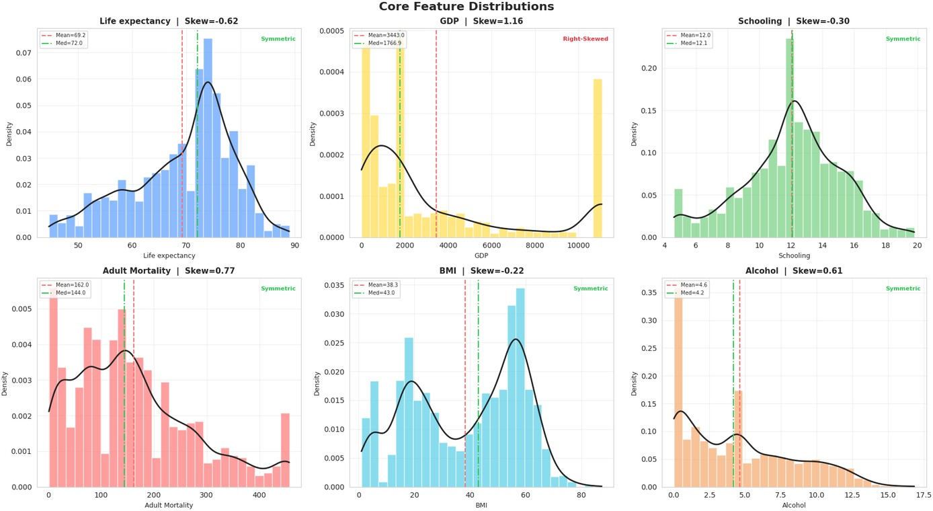
Figure 4.2 — Core Feature Distributions with KDE, Mean and Median Reference Lines

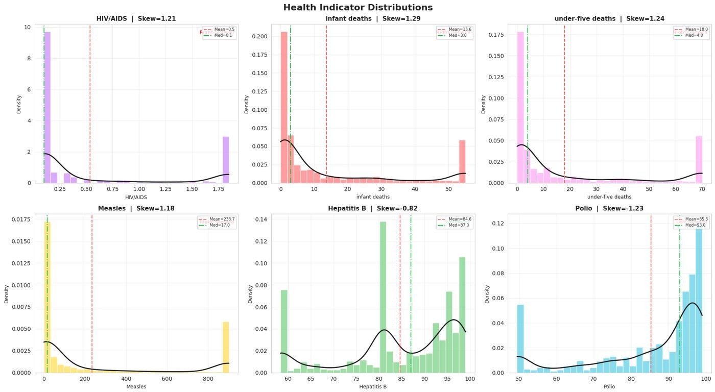
Figure 4.3 — Health Indicator Distributions: HIV/AIDS, Infant Deaths, Measles, Hepatitis B, Polio

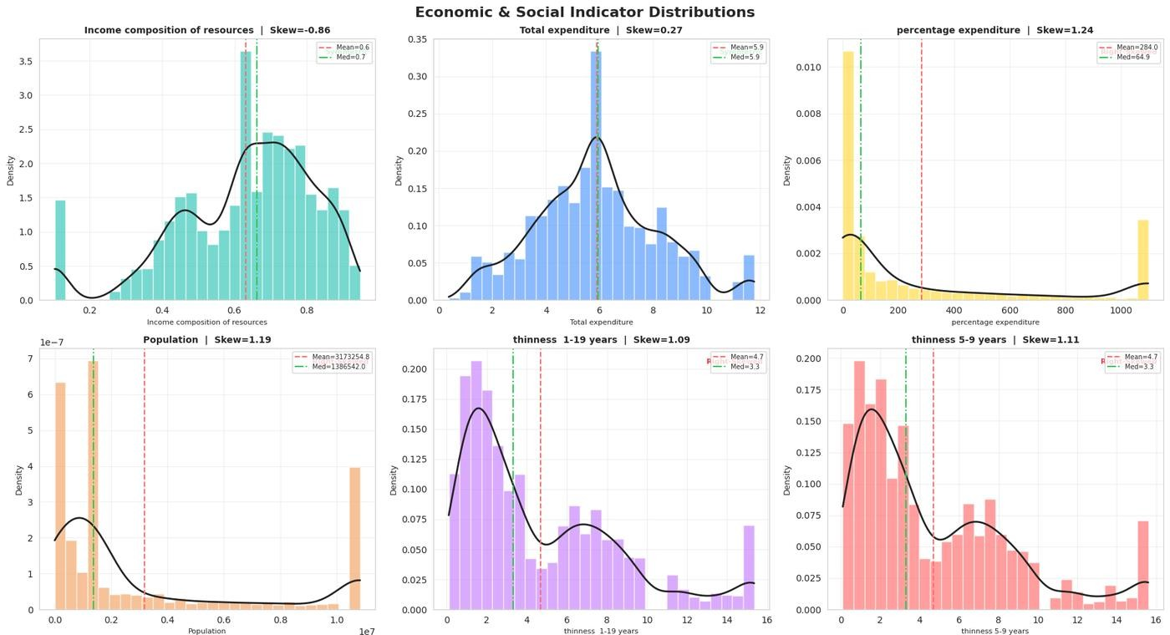
Figure 4.4 — Economic & Social Indicator Distributions

Development Status Distribution
The dataset contains 2,426 records (82.4%) from Developing nations and 512 records (17.6%) from Developed nations — a class ratio of approximately 4.7:1. This real-world asymmetry must be considered in all group comparisons: statistical conclusions about Developed nations are based on a much smaller sample and carry wider uncertainty intervals.
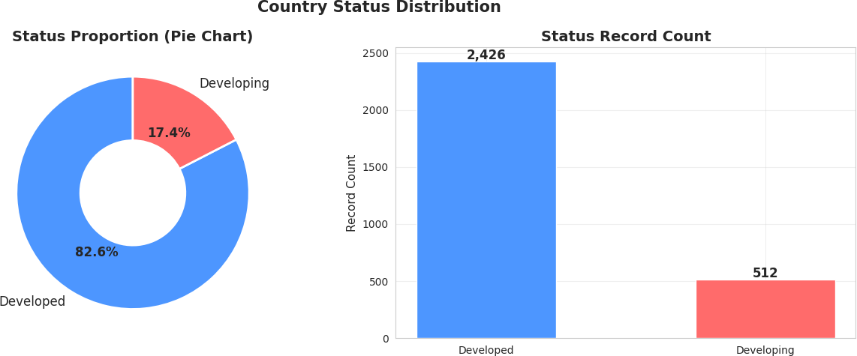

Figure 4.5 — Development Status Distribution: Proportion and Record Count

Bivariate Analysis
Bivariate analysis investigated pairwise relationships between features and the target variable. Scatter plots with OLS trend lines and Pearson correlation coefficients (r) were used throughout.

Economic Factors vs Life Expectancy
GDP shows a clear positive stepwise relationship with life expectancy when grouped into quartiles, spanning a 13-year gap from the lowest quartile (~64 years) to the highest (~77 years). Scatter analysis confirms that the relationship is nonlinear at the extremes, with rapidly diminishing returns at very high GDP levels. Some high-life-expectancy Developing nations exist at relatively moderate GDP levels, suggesting that social investment can compensate for limited economic resources.

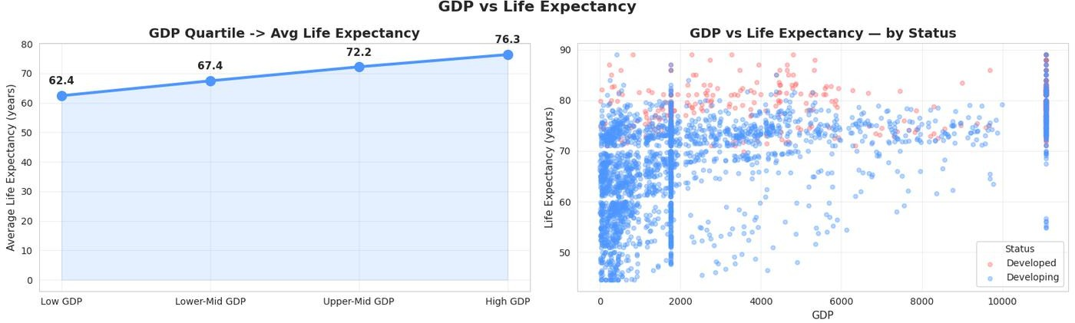

Figure 4.7 — GDP vs Life Expectancy: Quartile Line Chart (left) and Scatter by Status (right)

Social and Health Factors vs Life Expectancy
Schooling emerges as the strongest positive predictor with r ≈ +0.75, displaying a steep linear trend — each additional year of average schooling correlates with approximately 1.5–2 additional years of life expectancy. Income Composition of Resources follows closely at r ≈
+0.72, exhibiting the most consistent and near-linear positive relationship of any variable. HIV/AIDS prevalence is the strongest negative social predictor at r ≈ −0.57, with Sub-Saharan African nations forming the entire lower-right extremity of the scatter. Adult Mortality leads all negative correlations at r ≈ −0.70, confirming its role as a universal reducer of life expectancy. Diphtheria and Polio immunization coverage show moderate positive correlations (r ≈ +0.48 and
+0.46 respectively), where vaccination rates serve as proxies for overall healthcare system strength.
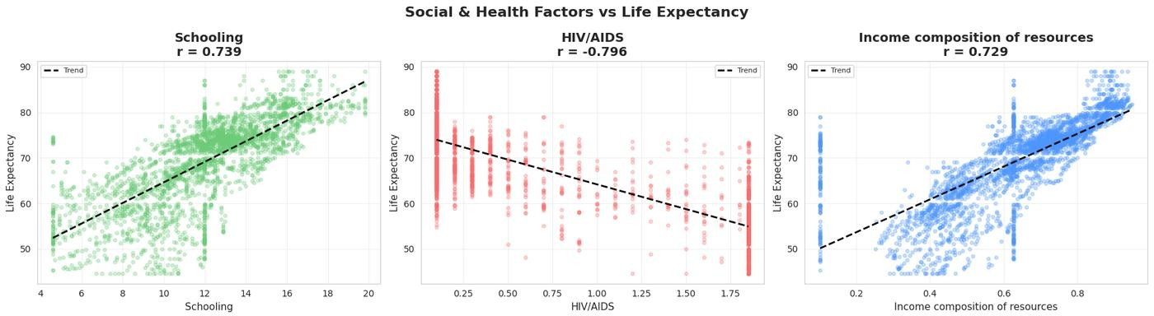

Figure 4.8 — Schooling (r≈+0.75), HIV/AIDS (r≈−0.57), Income Composition (r≈+0.72) vs Life Expectancy

Temporal Trends (2000–2015)
Global life expectancy rose from approximately 67 years in 2000 to 72 years in 2015 — a five- year global improvement. Schooling increased consistently year-over-year, reflecting global investment in education. Adult mortality showed a gradual downward trend, particularly accelerating after 2005. HIV/AIDS prevalence peaked around 2004–2005 and then declined sharply — the direct result of the PEPFAR and UNAIDS antiretroviral treatment programmes that expanded access to life-saving medication in Sub-Saharan Africa. GDP showed a generally increasing trend with a brief plateau around 2008–2009, corresponding to the global financial crisis.
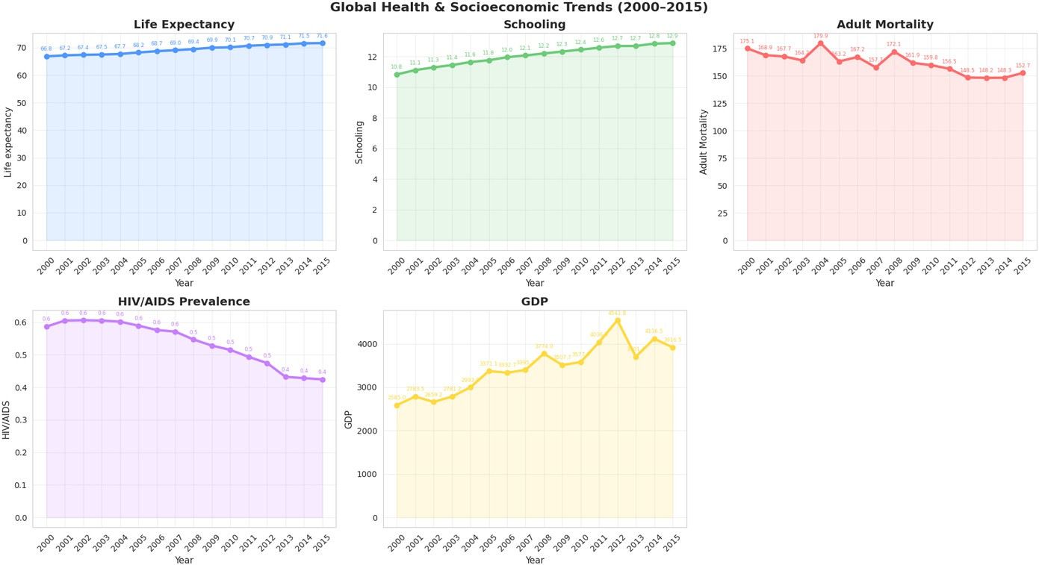

Figure 4.13 — Global Trends (2000–2015): Life Expectancy, Schooling, Adult Mortality, HIV/AIDS, GDP

Development Status Gap Over Time
Both Developed and Developing nations showed upward trajectories throughout 2000–2015, but at roughly equal rates — the gap between them barely narrowed. A bar chart of the annual gap confirms that it hovered persistently around 11–12 years throughout the entire period, with only marginal reduction toward 2015. This finding strongly suggests that economic growth alone does not close the global health divide — structural differences in education, governance, and healthcare infrastructure maintain the gap.
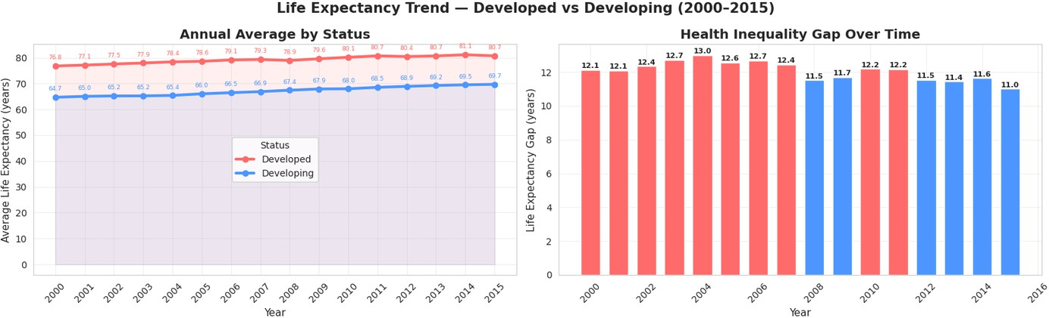

Figure 4.14 — Life Expectancy Trend by Development Status (left) and Health Inequality Gap (right)

Country Rankings
The top 10 countries by average life expectancy (2000–2015) are exclusively high-income nations — Japan, Sweden, Iceland, Switzerland, and similar — all averaging above 80 years. The bottom 10 are concentrated in Sub-Saharan Africa — Sierra Leone, Central African Republic, Lesotho, and others — all averaging below 50 years. The 30+ year gap between the global top and bottom represents the starkest illustration of global health inequality and provides the definitive answer to the project's central question.
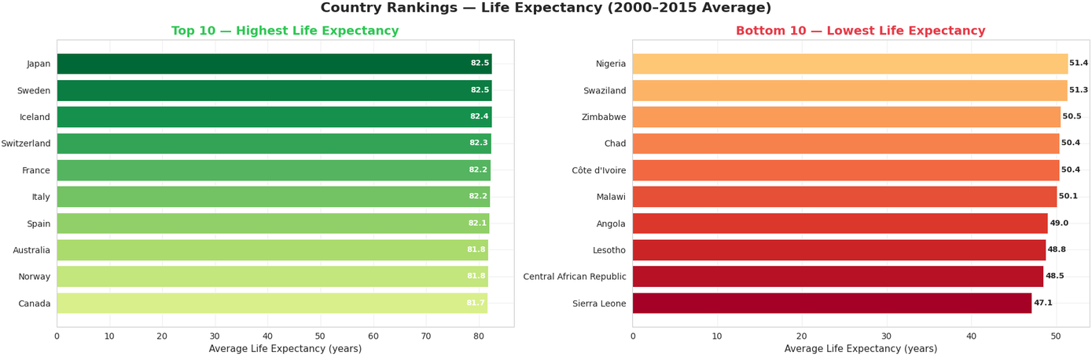
Figure 4.15 — Country Rankings: Highest and Lowest Average Life Expectancy (2000–2015)

Multivariate Analysis

Full Correlation Heatmap
The Pearson correlation heatmap visualizes all pairwise linear relationships simultaneously. Key observations: Income composition and Schooling both exceed r = +0.70 with Life expectancy. Adult Mortality and HIV/AIDS are the strongest negative correlates. Infant deaths and under-five deaths display a near-perfect correlation of r ≈ +0.99, confirming near-perfect multicollinearity. No unexpected spurious correlations were detected, validating the integrity of the cleaned dataset.
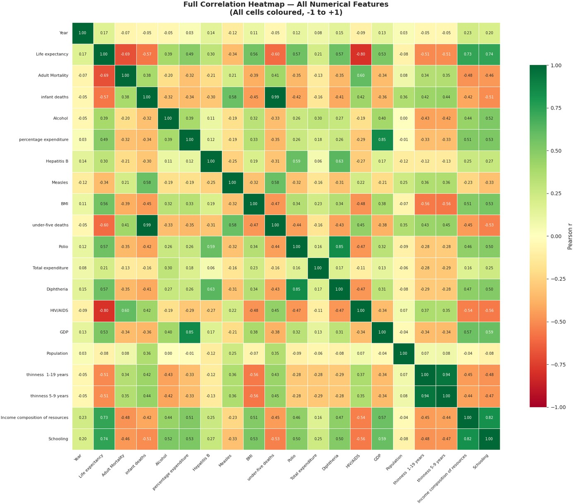
Figure 4.17 — Full Pearson Correlation Heatmap of All Numerical Features

3D Scatter Analysis
A three-dimensional scatter plot of GDP, Schooling, and Life Expectancy — coloured by development status — reveals that both dimensions must be simultaneously elevated to consistently achieve high life expectancy. The Developed cluster occupies the upper-right-top

corner of the space. Notably, some Developing nations with moderate schooling but low GDP still achieve 65+ years of life expectancy, reinforcing the finding that educational investment yields health dividends even without proportional economic growth.
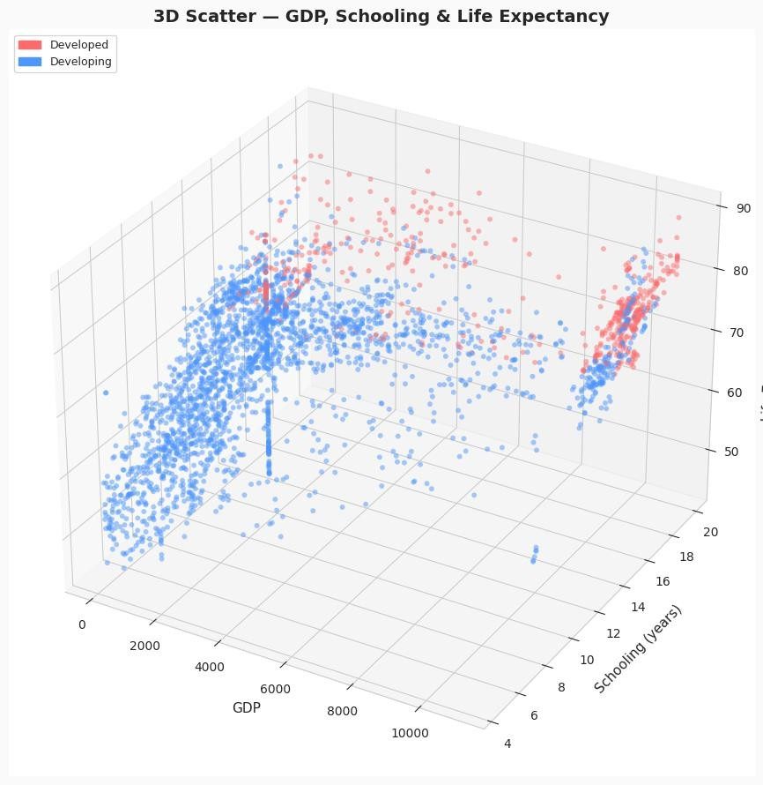

Figure 4.19 — 3D Scatter Plot: GDP, Schooling, and Life Expectancy Coloured by Development Status

Chapter 5: Data Transformation and Feature Engineering

Overview
Feature engineering transforms the cleaned dataset from an analysis-ready state into a model- ready state. Four sequential transformations were applied in a carefully ordered pipeline: label encoding, log transformation, MinMax normalisation, and Z-score standardisation. Each step addresses a specific mathematical requirement for downstream analysis and machine learning applications.

Label Encoding
The categorical Status column ('Developed' / 'Developing') was encoded to binary integers using scikit-learn's LabelEncoder. The alphabetical assignment mapped 'Developed' → 0 and 'Developing' → 1. Record counts were preserved exactly — 512 Developed records (0) and 2,426 Developing records (1) — confirming no data loss. This binary encoding is appropriate because Status is a dichotomous feature with no ordinal hierarchy.
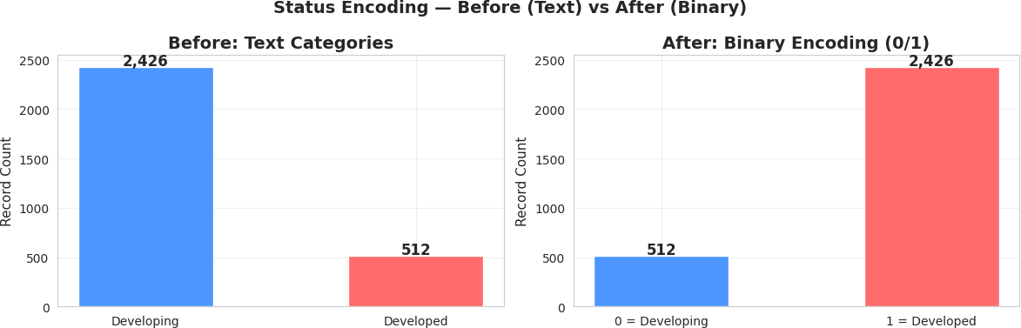

Figure 6.1 — Label Encoding: Development Status Before (Text) vs After (Binary 0/1)

Log Transformation for Skewness Correction
Six highly right-skewed features — GDP, Population, Measles, HIV/AIDS, infant deaths, and under-five deaths — underwent log1p transformation (applying log(1 + x) to safely handle zero values). The transformation was highly effective for most features: GDP skewness dropped from
1.156 to −0.706, Measles from 1.185 to near-zero (0.174), and infant deaths from 1.289 to
0.326. HIV/AIDS showed the most stubborn residual skewness at 1.102, reflecting the extreme concentration of disease burden in a small number of nations. However, all six features became substantially more symmetric, improving the validity of subsequent linear methods.

MinMax Normalisation
MinMax normalisation was applied to all 21 numerical features using scikit-learn's MinMaxScaler, mapping every feature to the range [0, 1] via the formula x_norm = (x − x_min)
/ (x_max − x_min). Post-scaling verification confirmed that every feature achieved a minimum of exactly 0.0 and a maximum of exactly 1.0. The relative ordering of values within each feature was fully preserved — MinMax scaling is a monotonic transformation that loses no information. This uniform scale eliminates the bias that distance-based algorithms would otherwise assign to high-magnitude features like GDP relative to bounded indicators like immunization coverage percentages.

Z-score Standardisation
StandardScaler was subsequently applied to the MinMax-normalized feature matrix, transforming each feature to have mean = 0 and standard deviation = 1 via z = (x − μ) / σ. Post- standardisation verification confirmed all feature means at approximately 0.0 and all standard deviations at approximately 1.0. This zero-mean, unit-variance property is a mathematical prerequisite for PCA, as the algorithm's covariance computation assumes centered data. Applying standardisation after MinMax normalisation ensured both scale uniformity and zero- centering.

Post-Transformation Validation
A post-transformation correlation heatmap confirmed that all four transformations preserved the correlation structure identified in EDA. Pearson correlation is scale-invariant under linear transformations, so scaling and standardisation produce no change. The slight shifts from log transformation were negligible, confirming the pipeline did not introduce any distortions. The transformed dataset was ready for PCA application in the subsequent phase.

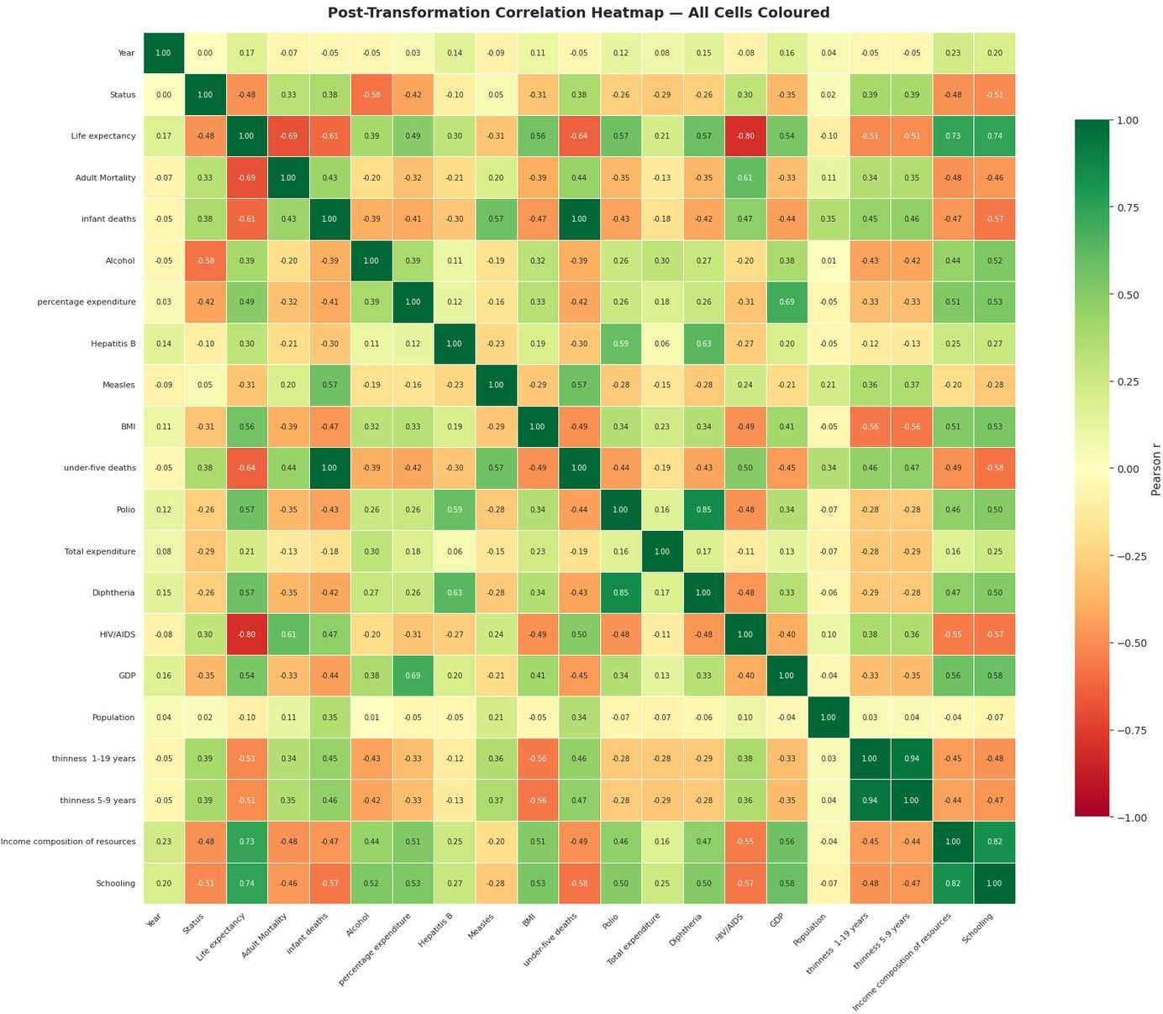

Figure 6.2 — Post-Transformation Correlation Heatmap (all features after full transformation pipeline)

Chapter 6: Advanced Analysis

Correlation Analysis
The full Pearson correlation matrix (presented in Chapter 4, Figure 4.17) was analysed to identify both strong predictors of life expectancy and problematic multicollinearity between features. The analysis yielded a clear ranking of feature associations with the target variable. Income composition of resources (+0.72) and Schooling (+0.75) are the strongest positive predictors. Adult Mortality (−0.70) and HIV/AIDS (−0.57) are the strongest negative predictors. At the feature-to-feature level, infant deaths and under-five deaths exhibited near-perfect multicollinearity (r ≈ +0.99), as did thinness 1-19 years and thinness 5-9 years (r > +0.90). These redundant feature pairs were identified for removal prior to PCA.
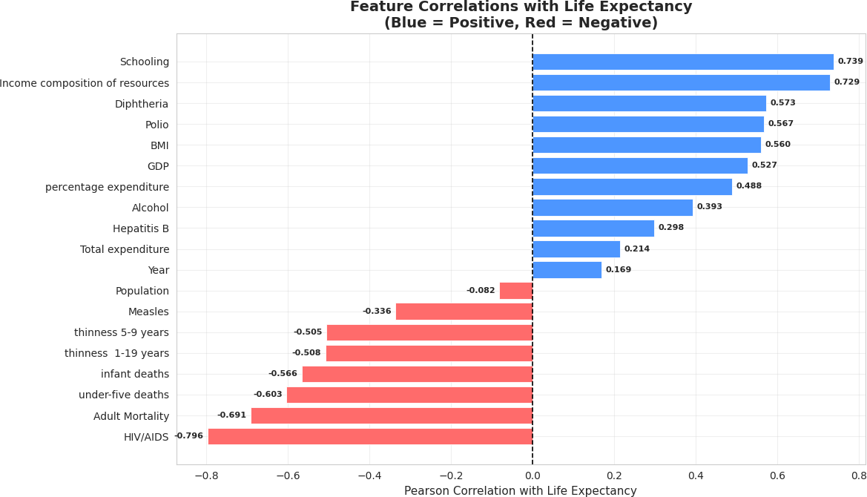

Figure 4.18 — Feature Correlations with Life Expectancy (Blue = Positive, Red = Negative)

Feature Selection
A correlation-based feature selection approach was applied prior to PCA. An upper triangular correlation matrix of absolute values was computed, and any feature with a pairwise correlation exceeding 0.90 with another feature was flagged for removal. This resulted in the removal of under-five deaths (r > 0.99 with infant deaths) and thinness 5-9 years (r > 0.90 with thinness 1- 19 years). The target variable Life expectancy was also excluded from the PCA input matrix, as PCA should only operate on predictor features. The final input matrix for PCA comprised 18 features from the original 22.

Principal Component Analysis (PCA)

Methodology
PCA was applied to the standardised 18-feature predictor matrix. The algorithm performs eigendecomposition of the covariance matrix, returning principal components ordered by descending explained variance. Each principal component is a weighted linear combination of the original features — the weights, called loadings, quantify each feature's contribution to that component. The strong inter-feature correlations identified during EDA provided the theoretical basis for effective PCA compression: when features share variance, the data's intrinsic dimensionality is lower than the nominal feature count.

Explained Variance

Component | Variance Explained | Cumulative | Interpretation
PC1 | 36.8% | 36.8% | Development & Health Axis (income, schooling, mortality, HIV/AIDS)
PC2 | 9.9% | 46.7% | Economic Investment Axis (GDP, health expenditure)
PC3 | 7.6% | 54.3% | Demographic Scale Axis (population, age structure)
PC4–PC12 | 35.7% | 90.0% | Residual health, immunization, and regional variance
Table 7.1 — PCA Component Variance Summary

The scree plot confirms the classic elbow shape: PC1 captures a dominant 36.8% of total variance, followed by a steep drop to PC2 at 9.9% and PC3 at 7.6%. The cumulative variance curve crosses the 90% threshold at component 12, indicating moderate compressibility — the dataset has multiple independent axes of variation (development level, economic investment, demographic scale) that cannot be fully collapsed.

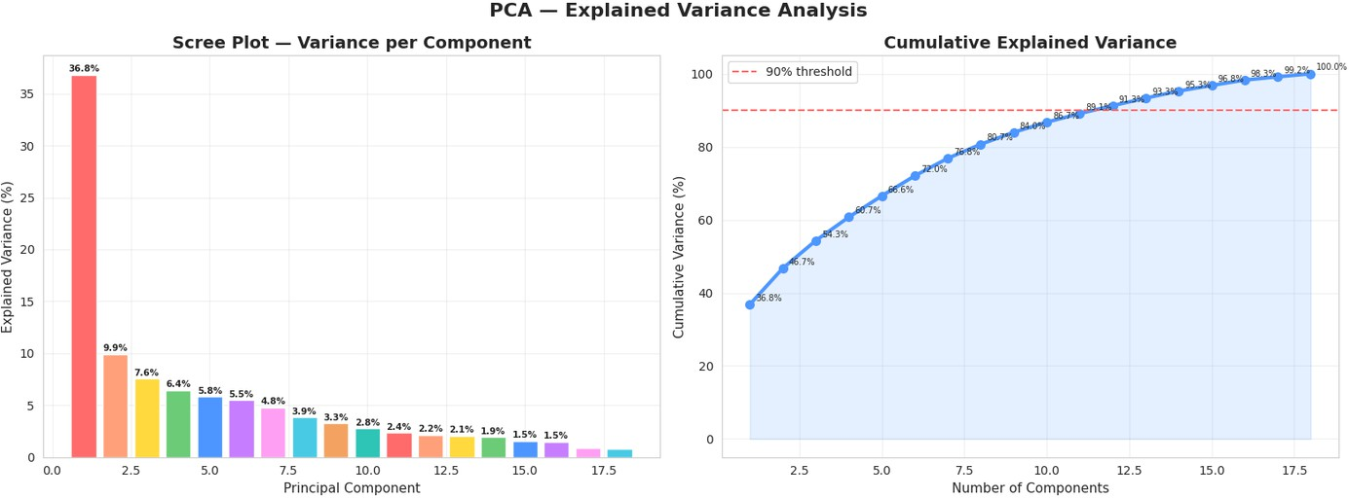

Figure 7.1 — PCA Scree Plot (left) and Cumulative Explained Variance Curve (right)

Visualization of Components
The 2D PCA projection (PC1 vs PC2) demonstrates clear spatial separation between Developed and Developing nations along the PC1 axis. Developed nations cluster in the positive PC1 region, confirming PC1's role as the Development and Health Axis. The continuous gradient overlay reveals that development status is not a sharp binary boundary but a continuous spectrum. Adding PC3 in the 3D projection reveals additional sub-clustering related to population scale and demographic structure.
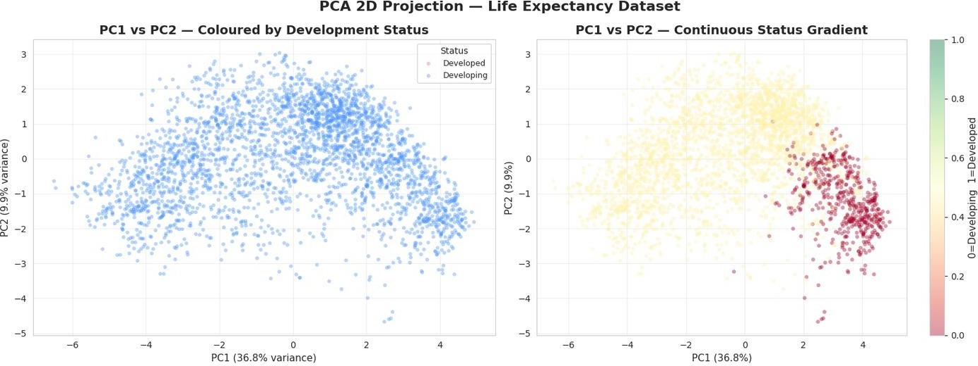
Figure 7.2 — PCA 2D Projection: Binary Status (left) and Continuous Development Gradient (right)

Component Interpretation via Loading Heatmap
The loading heatmap for PC1 through PC6 enables real-world interpretation of each component. PC1 loads positively on Income composition, Schooling, Diphtheria, and Polio, and negatively on Adult Mortality, HIV/AIDS, and infant deaths — it is the Development and Health Axis. PC2 loads strongly on GDP and Percentage Expenditure — it is the Economic Investment Axis, separating nations by their financial commitment to health independent of development status.

PC3 and beyond capture progressively specific patterns related to demographics, regional disease profiles, and vaccination heterogeneity.
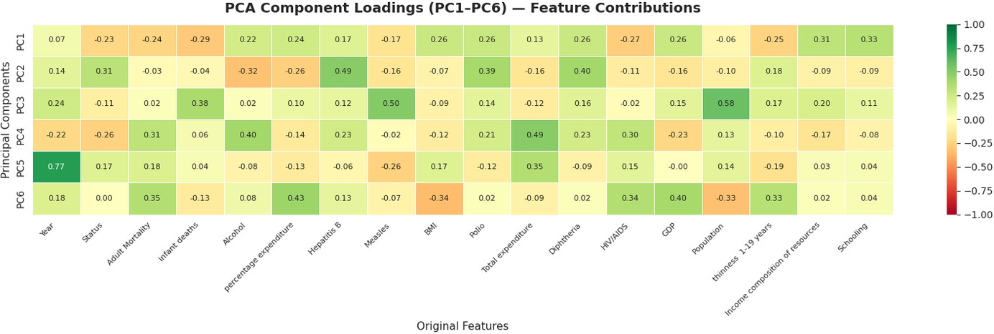

Figure 7.3 — PCA Component Loading Heatmap: Feature Contributions to PC1–PC6
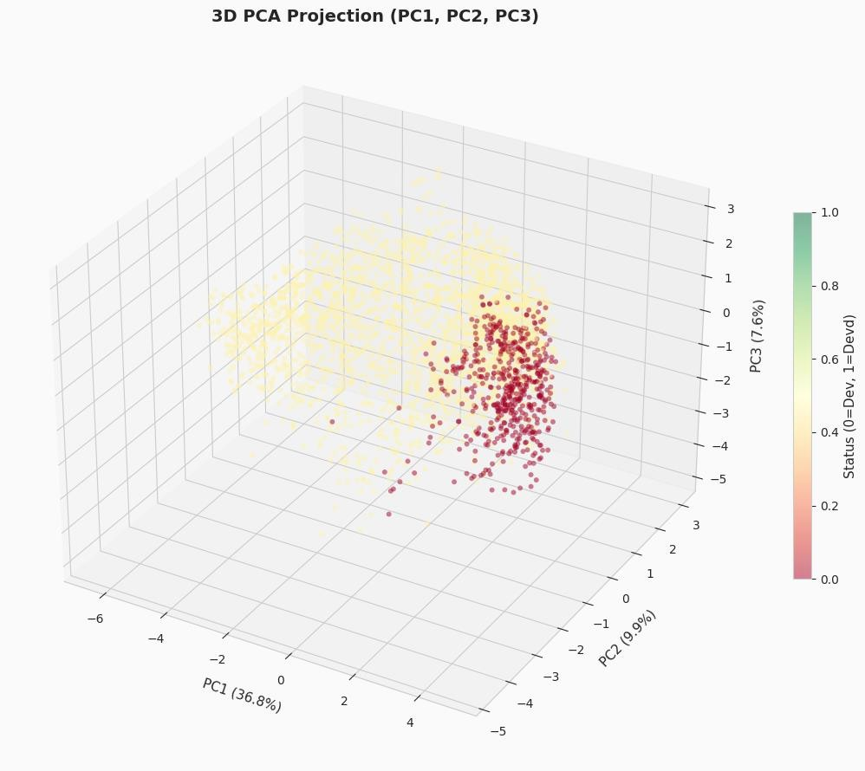
Figure 7.4 — 3D PCA Projection: PC1, PC2, PC3 Coloured by Development Status

Chapter 7: Visualization and Dashboard

Tools and Technologies Used
For this project, Power BI was used as the primary visualization tool. It is a business analytics platform developed by Microsoft that enables the creation of interactive dashboards and the effective visualization of large and complex datasets.
Using Power BI, various data insights were presented in a clear and intuitive manner, making it easier to identify patterns, trends, and key relationships within the data. The tool also provides a user-friendly drag-and-drop interface, which simplifies the process of building visual reports without extensive coding.
In addition, Power BI supports real-time data analysis and seamless integration with multiple data sources, enhancing its capability to handle dynamic and diverse datasets efficiently.

Types of Visualizations Produced
In this project, several visualizations were created to analyze the relationship between economic and health factors influencing life expectancy:

Scatter Plot (GDP vs Life Expectancy)
This visualization illustrates the relationship between a country’s GDP and its life expectancy, where each point represents an individual country. A positive correlation can be observed between the two variables.

👉 Insight: Countries with higher GDP generally tend to have higher life expectancy.

Column Chart (GDP Category vs Life Expectancy)
In this chart, GDP values were categorized into Low, Medium, and High groups, and the corresponding average life expectancy for each category was displayed.

👉 Insight: Life expectancy consistently increases with higher GDP categories.

Scatter Plot (Schooling vs Life Expectancy)
This plot highlights the relationship between the level of education (schooling) and life expectancy across countries.

👉 Insight: Higher levels of education are associated with longer life expectancy.

Immunization vs Life Expectancy Chart
This visualization compares immunization rates (such as Polio and Diphtheria) with life expectancy, showing the impact of healthcare access on lifespan.

👉 Insight: Countries with higher immunization coverage tend to have better life expectancy.

Filled Map (Life Expectancy by Country)
A geographical representation of life expectancy across different countries, allowing for regional comparison.

👉 Insight: Developed countries generally exhibit higher life expectancy compared to developing nations.

Dashboard Description
The dashboard is designed to provide a clear, interactive, and comprehensive overview of the key factors affecting life expectancy. It integrates multiple visualizations to present data insights in an intuitive and user-friendly manner.
The scatter plot highlights the relationship between GDP and life expectancy, enabling users to observe economic influence on health outcomes. The column chart offers a grouped comparison of different economic levels, making it easier to analyze variations across categories.
Additionally, the education and immunization visuals emphasize the impact of social and healthcare factors on life expectancy, while the map visualization provides a global perspective by illustrating geographical distribution. The Key Influencers visual further enhances the analysis by identifying the most significant factors contributing to changes in life expectancy.
The dashboard also supports interactivity through filters and slicers, allowing users to explore the data in greater detail. Users can select specific countries, compare developed and developing regions, and analyze trends across multiple variables.
Overall, the dashboard effectively demonstrates how economic growth, education, and healthcare collectively contribute to improvements in life expectancy.
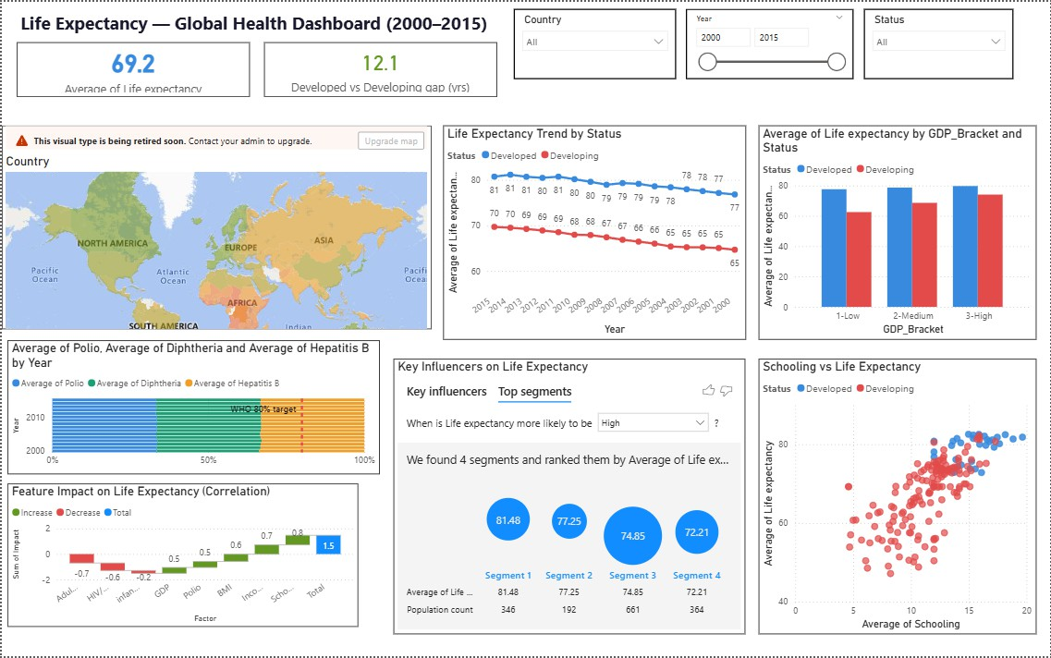

Chapter 8: Insights and Storytelling

Key Findings from Analysis
Seven weeks of systematic analysis yielded a coherent, evidence-backed answer to the central research question. The findings are organized below by analytical domain:

Education Outperforms Wealth as a Life Expectancy Predictor
Schooling (r ≈ +0.75) and Income Composition of Resources (r ≈ +0.72) both outperform raw GDP as predictors of life expectancy. This is a critical finding: it suggests that the mechanism by which economic development improves health outcomes is primarily mediated through education and equitable income distribution, rather than GDP magnitude alone. Nations that invest in universal education and reduce income inequality — even at moderate GDP levels — consistently achieve better health outcomes than nations that accumulate GDP without structural social investment.

The HIV/AIDS Factor
HIV/AIDS prevalence emerges as a compound multiplier of health disadvantage. Its strong negative correlation with life expectancy (r ≈ −0.57) is compounded by its near-exclusive concentration in Sub-Saharan Africa, which also suffers from the lowest schooling years, weakest income composition, and lowest immunization coverage. This geographic clustering means HIV/AIDS is not merely a disease driver — it is a proxy indicator for the full constellation of development deficits that define the world's most health-disadvantaged nations. The observed decline in HIV/AIDS prevalence after 2004–2005, attributable to PEPFAR and UNAIDS interventions, represents one of the most successful examples of targeted international health policy driving measurable population-level improvements.

The Persistent Development Gap
Despite both Developed and Developing nations improving throughout 2000–2015, the 11–12 year life expectancy gap between the two groups was remarkably stable across the entire period. This finding challenges the optimistic narrative that economic growth automatically converges health outcomes over time. The pivot heatmap evidence confirms that Developing nations improved from approximately 65 to 69 years (a 4-year gain) while Developed nations improved from approximately 77 to 79 years (a 2-year gain) — the gap narrowed by only 2 years in 15 years at this rate. Structural investments in healthcare infrastructure, governance, and education quality are prerequisites for genuine convergence.

Patterns and Trends Identified
- A bimodal life expectancy distribution reveals two globally distinct health regimes: a high-expectancy cluster (primarily high-income nations) and a low-expectancy cluster (primarily Sub-Saharan African nations).
- Disease burden indicators (infant deaths, under-five deaths, r ≈ 0.99 collinearity) show that child mortality is the primary single driver of national life expectancy divergence.
- Immunization coverage (Hepatitis B, Polio, Diphtheria) shows a world divided between well-vaccinated and under-vaccinated populations, with the latter corresponding almost entirely to the low life expectancy cluster.
- The near-linear income composition vs life expectancy relationship confirms that equitable income distribution yields consistent health dividends across the full development spectrum.
- Log transformation confirmed that economic variables follow power-law-like distributions — the difference between $1,000 and $5,000 GDP per capita has a far larger health effect than the difference between $50,000 and $100,000.

Business and Social Insights
- Health investment yields higher returns when targeted at education and income equality rather than GDP growth alone — this has direct implications for international development funding priorities.
- The 30-year life expectancy gap between Japan/Sweden and Sierra Leone/Central African Republic is not inevitable; it reflects decades of differential investment in health systems, education, and governance. Evidence-based interventions can narrow it.
- Sub-Saharan Africa requires targeted multi-dimensional interventions simultaneously addressing HIV/AIDS, childhood immunization, schooling access, and income inequality — single-issue interventions will have limited impact given the structural co- occurrence of deficits.
- The success of HIV/AIDS programs after 2005 demonstrates that coordinated global health initiatives, when adequately funded and implemented, can produce measurable population-level improvements within a decade.

Decision-Making Based on Results
The analytical findings yield several concrete, actionable recommendations for stakeholders in global health policy, public health governance, and development finance:
- Prioritize Education Investment: Policymakers seeking to improve population health outcomes should treat years of schooling as a primary leading indicator. Educational

expansion delivers health co-benefits through improved health literacy, employment quality, maternal health practices, and civic health governance.
- Use Income Composition as a Monitoring KPI: The Income Composition of Resources index provides a more sensitive early indicator of life expectancy trajectory than GDP alone. Nations showing improvement in income composition but stagnant GDP should be prioritized for continued development support.
- Target Immunization Gaps: Nations in the low-vaccination cluster should receive prioritized international support for Hepatitis B, Polio, and Diphtheria coverage expansion. The correlation evidence suggests these programs have reliable, scalable health outcome benefits.
- Sustain HIV/AIDS Programs: The post-2005 decline in HIV/AIDS prevalence and associated adult mortality confirms that antiretroviral treatment programs are among the highest-ROI health interventions available. Sustained funding is essential to maintain this trajectory.
- Address Child Mortality as the Primary Lever: Given the near-perfect collinearity between infant deaths, under-five deaths, and overall life expectancy, reducing child mortality through improved maternal healthcare, clean water access, and pediatric immunization represents the single most effective path to national life expectancy improvement.

Chapter 9: Conclusion

Summary of the Project
This seven-week project conducted a comprehensive, end-to-end data science investigation of the WHO Life Expectancy dataset, progressing systematically from raw data ingestion through profiling, cleaning, exploratory analysis, feature engineering, and dimensionality reduction. The central question — 'Does wealth truly buy a longer life?' — was answered with nuance: economic prosperity contributes significantly to life expectancy, but education, equitable income distribution, immunization coverage, and adult mortality reduction are equally or more important determinants. The 13-year life expectancy gap between low and high GDP quartile nations is real, but the 20-year gap associated with income composition and the 22-year gap between the poorest and richest schooling groups reveal that the returns on social investment exceed those of economic growth alone.

Outcomes Achieved
    - A complete, reproducible data science pipeline was implemented in Python, processing 2,938 records and 22 variables across all analytical stages.
    - 2,563 missing values were successfully imputed using a skewness-informed strategy, with zero records deleted.

    - Outlier capping via the IQR method preserved all records while bounding extreme values that would distort analysis.
    - Over 20 distinct visualizations were produced, collectively forming a coherent analytical narrative across seven weeks.
    - Feature correlation analysis identified Income composition (+0.72) and Schooling (+0.75) as the strongest positive predictors, and Adult Mortality (−0.70) as the strongest negative predictor of life expectancy.
    - PCA reduced 18 predictor features to 3 interpretable components capturing 54.3% of total variance, with PC1 identified as the Development and Health Axis.
    - Temporal analysis demonstrated a 5-year global improvement in life expectancy from 2000 to 2015, alongside a persistent 11–12 year Developed–Developing gap.

Limitations
    - Temporal Scope: The dataset covers only 2000–2015; more recent years (2016– present) may reflect different patterns driven by COVID-19, new vaccination programs, and evolving geopolitical conditions.
    - Missing Data Bias: Missing values were disproportionately concentrated in Developing nations, meaning the imputed values for these countries may underestimate variability and introduce a subtle smoothing bias in developing-country statistics.
    - Causal Inference: All correlations identified are associative, not causal. Reverse causality is plausible in several relationships — for instance, healthier populations may be more economically productive, contributing to GDP growth rather than solely being caused by it.
    - No Predictive Modelling: The project did not include regression or classification modelling, which would quantify the relative contribution of each feature to life expectancy while controlling for confounders.
    - Binary Development Status: The Developed/Developing binary classification obscures enormous heterogeneity within each group — particularly among Developing nations, which span Sub-Saharan Africa to rapidly developing East Asian economies.

Future Scope
    - Machine Learning Integration: Applying regression algorithms (Linear Regression, Random Forest, Gradient Boosting) to predict life expectancy and quantify feature importances with statistical significance.
    - Clustering Analysis: K-Means or hierarchical clustering applied to the PCA-reduced feature space to identify empirically derived groups of nations beyond the binary Developed/Developing classification.

    - Time Series Forecasting: Extending the analysis to project future life expectancy trajectories by country using ARIMA or LSTM models, incorporating recent post-2015 data.
    - Interactive Dashboard: Building a Streamlit or Dash web application that allows end- users to interactively filter by country, year, and development status to explore the visualizations dynamically.
    - Natural Language Reporting: Integrating automated insight generation using language models to produce country-specific health briefings from the analytical outputs.

Chapter 10: References

Dataset Sources
- Kumar Rajarshi. WHO Life Expectancy Dataset. Kaggle. Available at: https://www.kaggle.com/datasets/kumarajarshi/life-expectancy-who
- World Health Organization (WHO). Global Health Observatory. Available at: https://www.who.int/data/gho
- United Nations Development Programme (UNDP). Human Development Index. Available at: https://hdr.undp.org/data-center

Tools and Libraries Used
  - Pandas
  - NumPy
  - Matplotlib
  - Seaborn
  - Scikit-learn
  - SciPy
  - Power BI

Technical Documentation and References
  - Pandas isnull and describe documentation. - https://pandas.pydata.org/docs/reference/api/pandas.DataFrame.describe.html
  - scikit-learn PCA documentation. https://scikit- learn.org/stable/modules/generated/sklearn.decomposition.PCA.html
  - scikit-learn LabelEncoder. https://scikit- learn.org/stable/modules/generated/sklearn.preprocessing.LabelEncoder.html
  - scikit-learn MinMaxScaler. https://scikit- learn.org/stable/modules/generated/sklearn.preprocessing.MinMaxScaler.html

Research Articles and Learning Resources
  - Tukey, J.W. Exploratory Data Analysis. Addison-Wesley, 1977.
  - Towards Data Science — Exploratory Data Analysis Guide. https://towardsdatascience.com/exploratory-data-analysis-8fc1cb20fd15
  - Towards Data Science — A One-Stop Shop for Principal Component Analysis. https://towardsdatascience.com/a-one-stop-shop-for-principal-component-analysis- 5582fb7e0a9c
  - StatQuest with Josh Starmer — PCA Step by Step. https://www.youtube.com/watch?v=FgakZw6K1QQ
  - Geeks for Geeks — Interquartile Range to Detect Outliers. https://www.geeksforgeeks.org/interquartile-range-to-detect-outliers-in-data/
  - Towards Data Science — Feature Engineering Techniques. https://towardsdatascience.com/understanding-feature-engineering-part-1-continuous- numeric-data-da4e47099a7b
  - Real Python — Pandas Visualization Tutorial. https://realpython.com/pandas-plot- python/
  - United Nations SDG Portal — SDG 3: Good Health and Well-Being. https://sdgs.un.org/goals/goal3

Appendix :
GitHub link - https://github.com/varthanharsh35-ux/24ADI004_TEAM-2.git
Code Snippets :
1.4 Code — Library Import & Style Configuration
Code:
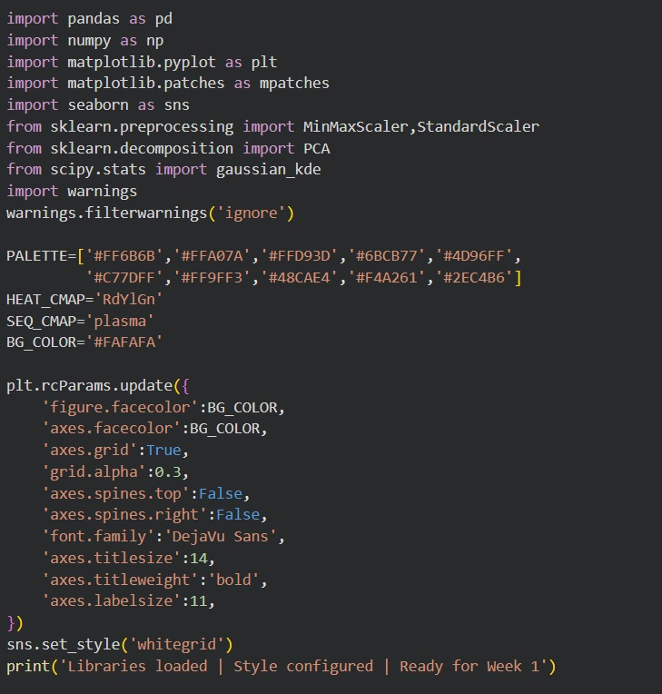

1.5 Code — Data Loading
Code:
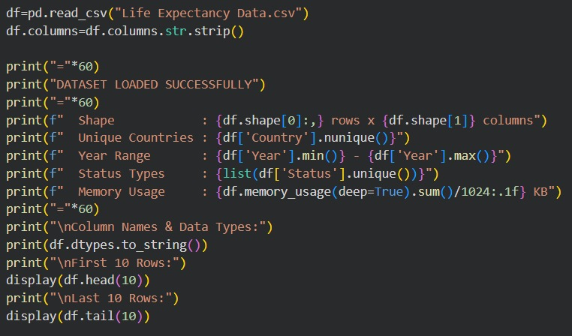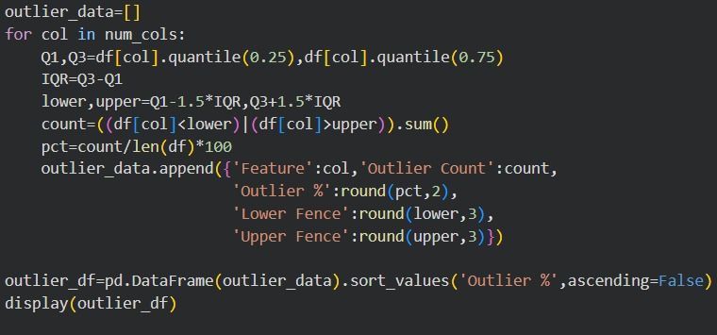

3.7 Code — Outlier Detection
Code:

3.10 Code — Export Cleaned Dataset
Code:
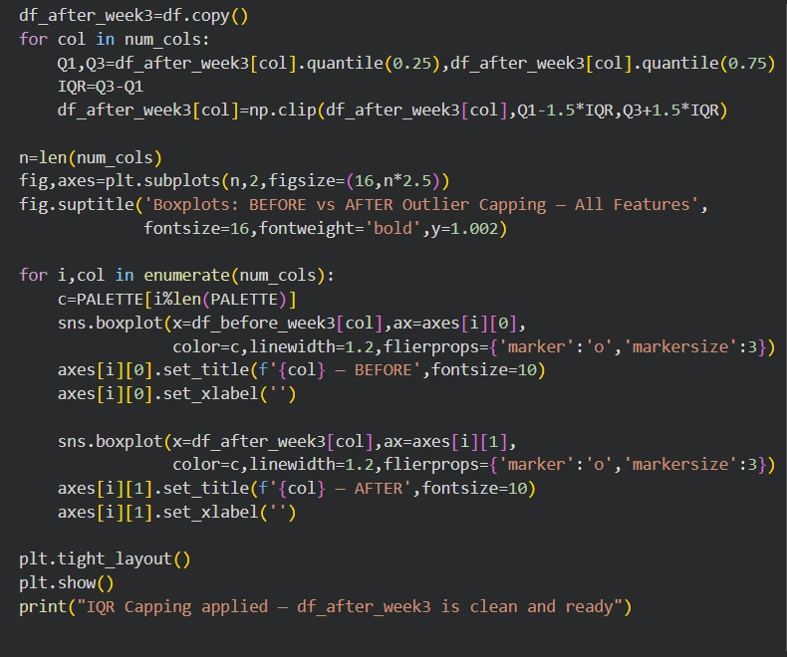
4.5.2 Schooling, HIV/AIDS, and Income Composition vs Life Expectancy
Code
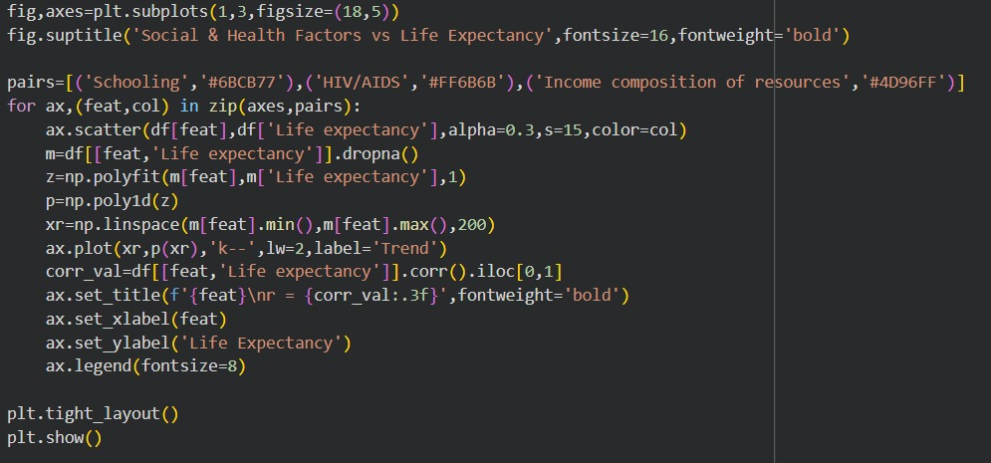:

4.5.9 Country Rankings — Top 10 and Bottom 10
Code:
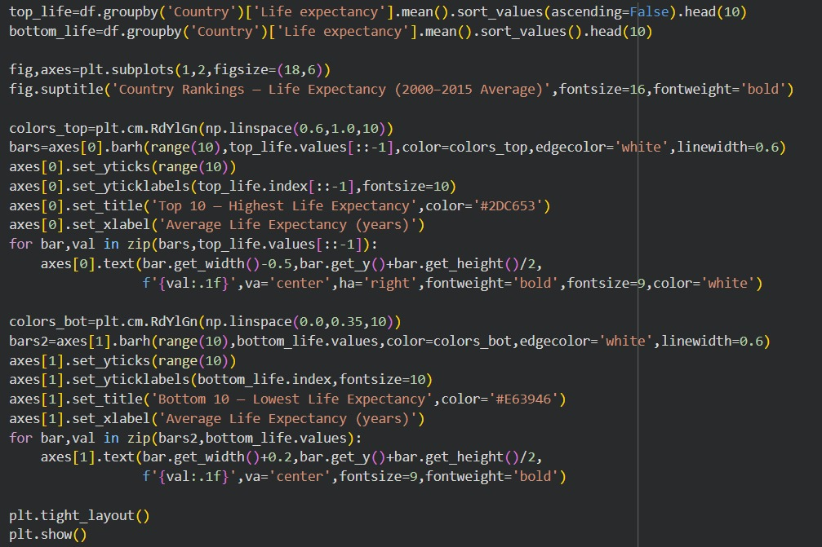

6.5 Code & Output — MinMax Normalisation
Code:
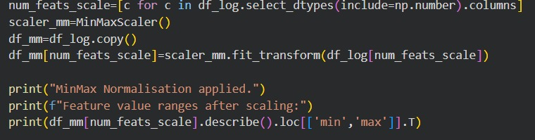

7.4 Visualization — PCA Scree Plot & Cumulative Variance
Code:
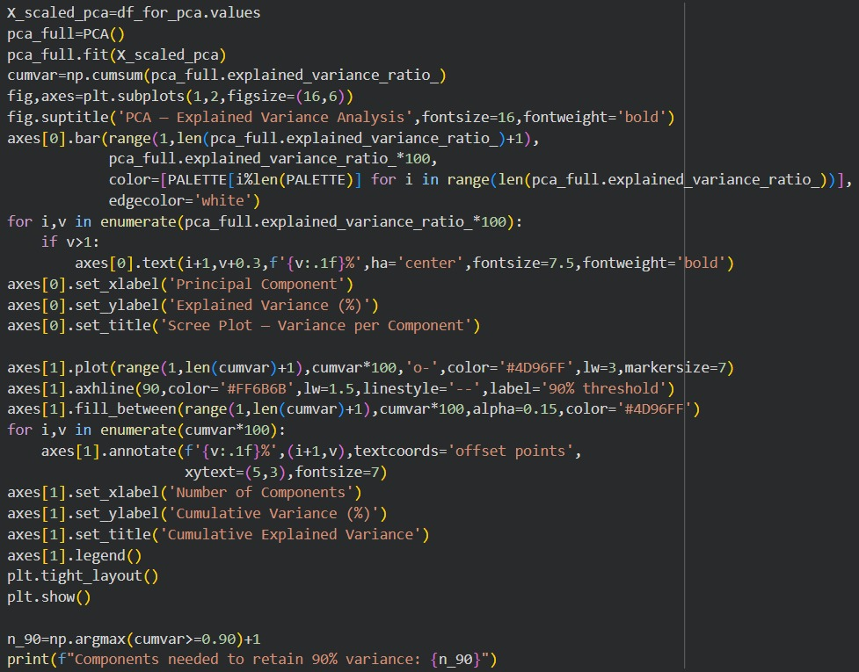

Additional Visuals
Year-wise Global Trends (2000–2015)

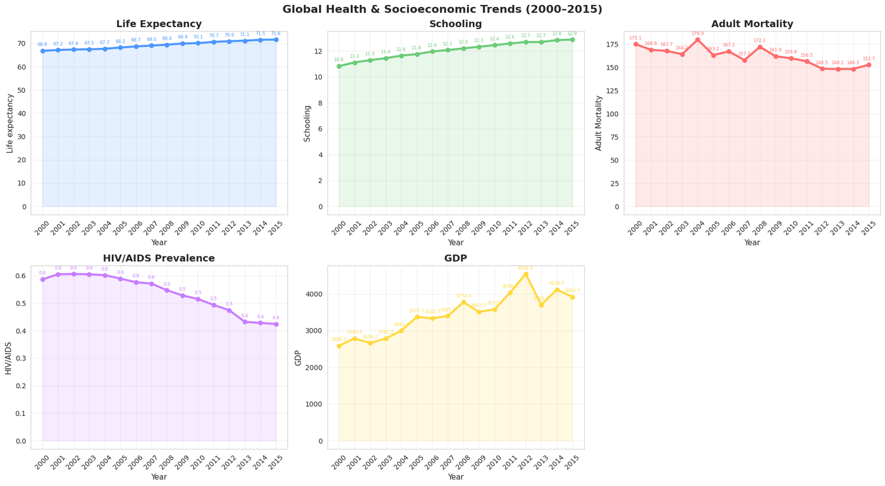

Pivot Heatmap:
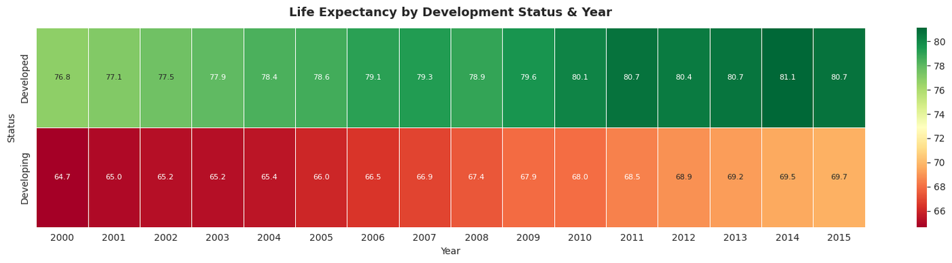

Pair Plot:

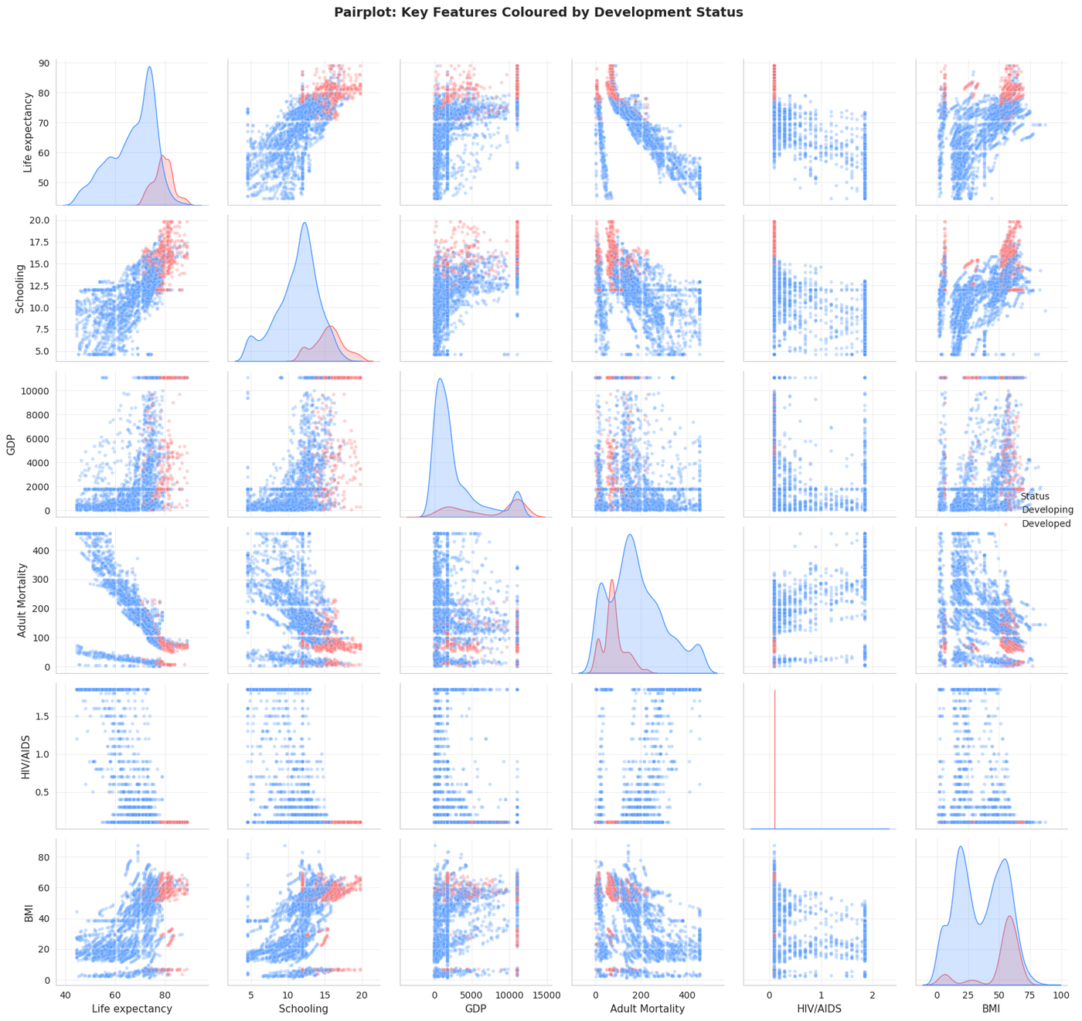

Strip Plots:
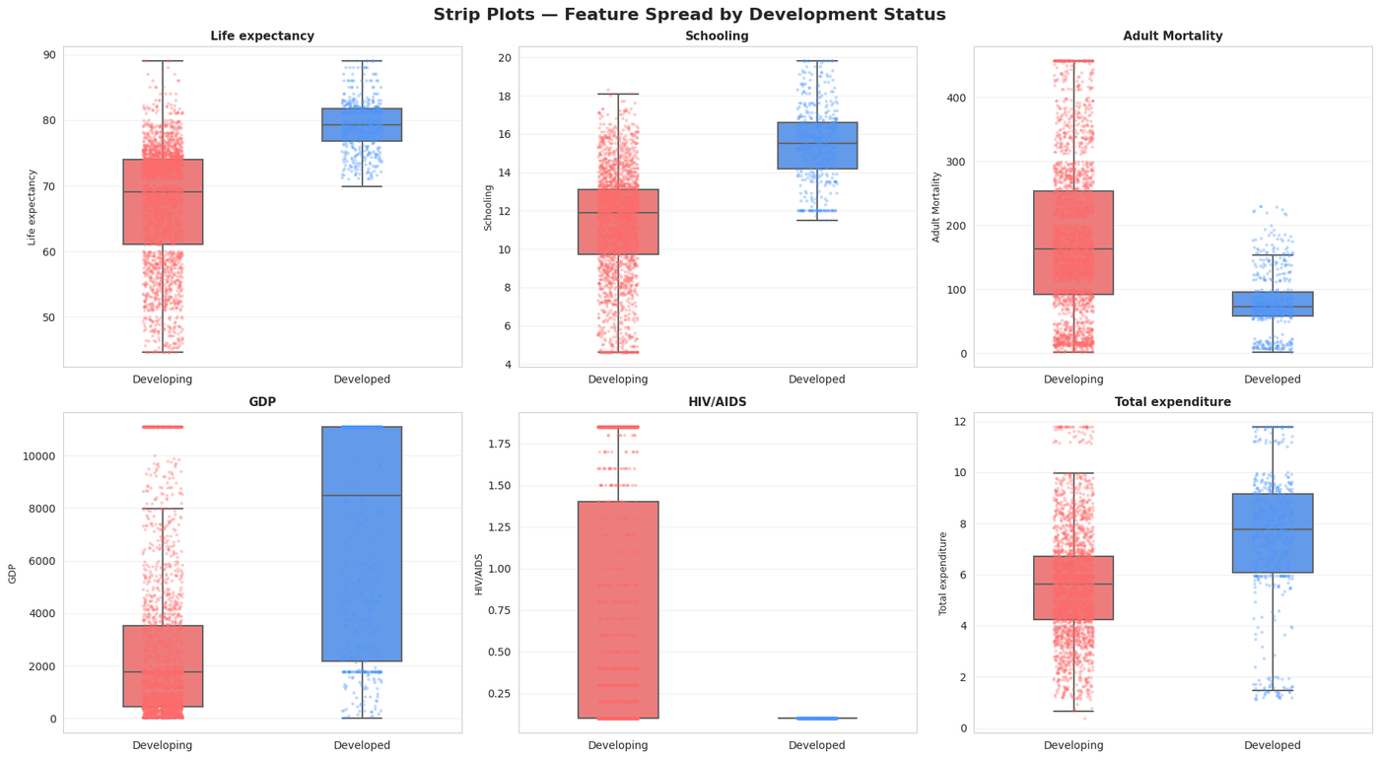
Health Indicator Distributions
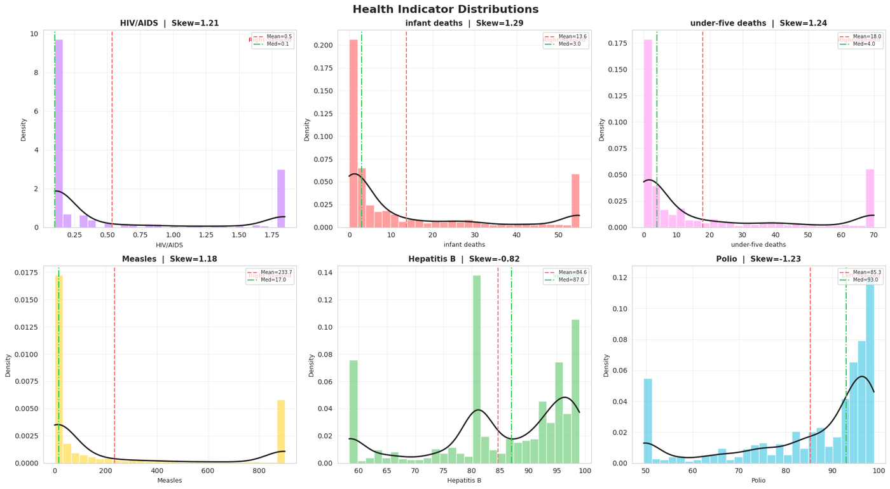

Development Status Distribution:
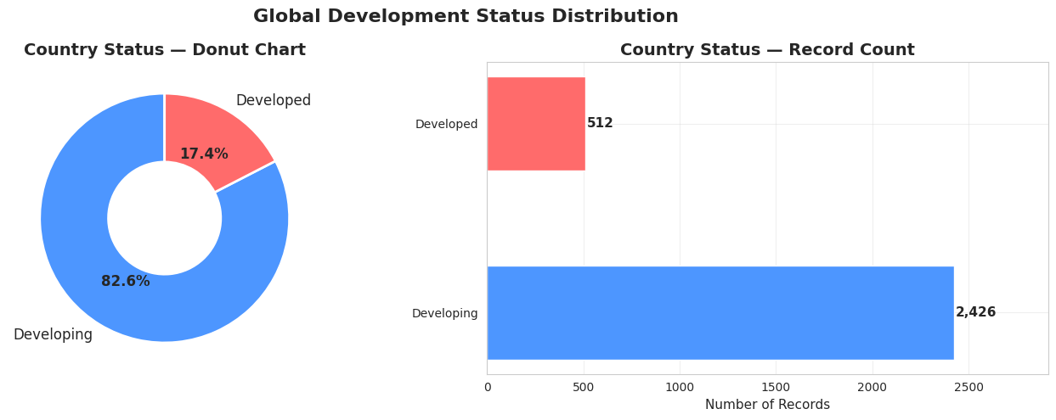

Missing Data Bar Chart:
